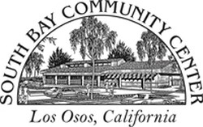

South Bay Community Center
Board of Directors

Special Meeting May 24, 2023
Minutes

Present: Gary Katayama (GK), Gary Dove (GD), Pam Hostetter (PH), Cherrie Katayama (CK), Michelle Feldman (MF), Richard Margetson (RM) arrived 8:50
Call to Order 8:35a.m.

- Nomination & Vote for office of Secretary. Michelle Feldman resigned as Vice President. Resignation accepted by the Board. MF accepted nomination as Secretary made by CK. Vote: unanimous approval

- Nomination of Gary Dove as CFO by GK and accepted by GD. Vote unanimous approval

- Nomination of Pam Hostetter for Vice President by CK. & accepted by PH. Vote unanimous approval
Richard Margetson joined at this point
- Review of Draft revised job description for General Manager for adoption & immediate posting. Motion to accept with revisions stipulated PH Second GD. Unanimous
Respectfully submitted,
Michelle Feldman, Secretary

